VULNERABILITY ASSESSMENT
&
PENETRATION TESTING REPORT

Target Domain: chime.com

Organization: SLBS Marklance

Submitted By: Sangamithra

Date of Submission: July 2026

INTRODUCTION

This internship project focuses on conducting a professional Vulnerability Assessment and Penetration Testing (VAPT) workflow against enterprise network assets. The assessment simulates real-world reconnaissance, active host discovery, automated scanning, and manual validation methodologies to identify potential risk factors, security misconfigurations, and information disclosure bugs on the target infrastructure.

TARGET SCOPE AND ENVIRONMENT

Technical Scope Breakdown

The security assessment parameters and environmental factors mapped for the target scope are detailed below:

- Target Infrastructure Specifications:

- Primary Target Domain: chime.com (Enforced via www.chime.com)

- Discovered Application Node: handbooks.chime.com

- Perimeter Defense Provider: Cloudflare Protected Edge Network

- Target Routing Endpoint: Routed through Cloudflare Proxy Layers (172.64.152.131 / 104.18.35.125)

Assessment Environment & Logic

- Testing Methodology: External Network Vulnerability Assessment & Web App VAPT

- Host Operating System: Kali Linux Development Environment (mithu@kalii)

- Execution Layer: Layer 7 Protocol Analysis & Automated Signature Inspection

SECURITY ASSESSMENT METHODOLOGY

The assessment was carried out in a structured, phased approach to ensure comprehensive coverage of the target infrastructure:

- Phase 1: Reconnaissance & Service Discovery: Utilizing passive and active mapping techniques (DNS interrogation, active host discovery, port scanning) to outline the external attack surface.

- Phase 2: Automated Vulnerability Assessment: Deploying template-based signature scanners and web server auditors to flag policy violations and infrastructure gaps.

- Phase 3: Manual Verification & Analysis: Performing low-level HTTP stream parsing to validate automated alerts and eliminate false positives.

INFORMATION GATHERING (RECONNAISSANCE)

DNS Reconnaissance (nslookup & dig)

To establish a baseline for the target infrastructure and discover the underlying IP routing, active DNS queries were performed.

Tools Used: nslookup & dig (Domain Information Groper)

Commands Executed: nslookup chime.com dig chime.com

Methodology & Impact: The DNS interrogation revealed multiple A records, specifically mapping the domain to the IP addresses 172.64.152.131 and 104.18.35.125. The results officially confirm that the target infrastructure is routed through a Cloudflare proxy network, which serves as a defensive edge layer.
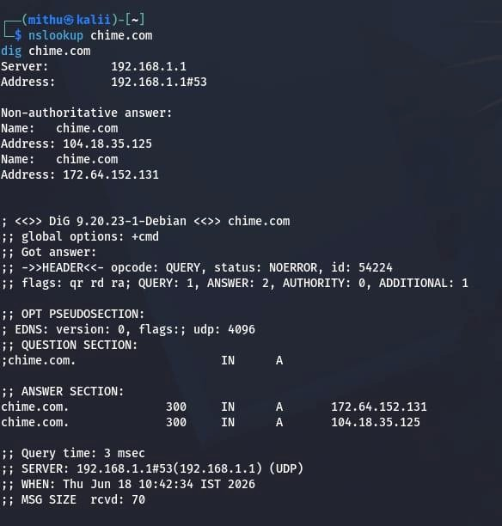
Figure 4.1: Active DNS lookup queries demonstrating Cloudflare proxy IP routing.

Active Host & Subdomain Filtering (httpx)

Following structural subdomain harvesting, active host discovery was executed to filter out dead assets and locate live, responsive HTTP web nodes.

Tool Used: httpx-toolkit

Command Executed:
~/go/bin/httpx -l all_subdomains.txt -sc -mc 200 -silent -o
200_subdomains.txt

Methodology & Impact: By parsing a pre-compiled subdomain wordlist through httpx, the scanner validated live HTTP responses. Multiple high-value infrastructure targets returned an explicit [200] HTTP OK status code, including developer.chime.com, handbooks.chime.com, status.chime.com, and flashpaper.chime.com, establishing the verified active attack surface.
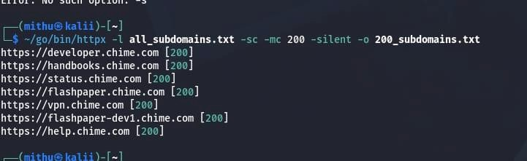
Figure 4.2: Automated host discovery pipeline logging verified active subdomains.

Port Scanning & Service Fingerprinting (Nmap)

To discover open entry points and determine the running service versions on the target layer, an active port scan was performed.

Tool Used: Nmap (Network Mapper)

Command Executed:
nmap -sV -Pn chime.com

Methodology & Impact: The -Pn flag bypassed ICMP blocking to scan the host behind
Cloudflare, while -sV determined service versions. The scan mapped out four open TCP ports: 80 (http), 443 (ssl/http), 8080 (http), and 8443 (ssl/http). All open ports explicitly returned a Cloudflare http proxy signature, confirming the perimeter defenses are active.

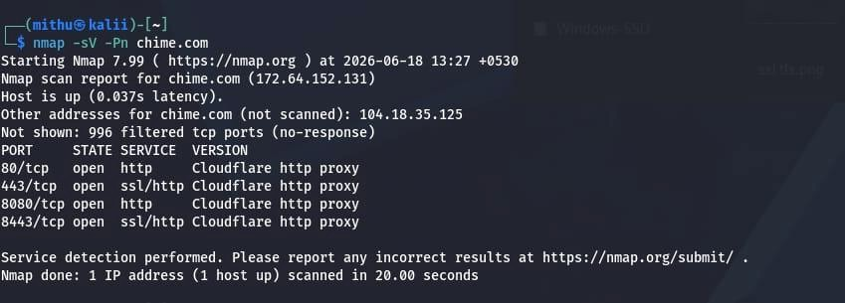
Figure 4.3: Nmap port scan output tracking open proxy entry points.

Web Technology Profiling (WhatWeb)

To footprint the underlying software frameworks and edge servers powering the main target, standard technology profiling was initiated.

Tool Used: WhatWeb

Command Executed:
whatweb https://www.chime.com

Methodology & Impact: The profiling request against the primary endpoint returned an HTTP
403 Forbidden status with a "Just a moment..." page title. This proves the active presence of Cloudflare's Web Application Firewall (WAF) blocks, while also capturing critical client-side parameters such as security cookies (__cf_bm) and anti-clickjacking directives (X-Frame-Options[SAMEORIGIN]).
Figure 4.4: WhatWeb structural technology profile showing WAF interaction.

HTTP Raw Header Parsing (curl)

To cross-examine the server response behavior and identify security directives enforced on the edge server, direct header requests were sent.

Tool Used: curl (Client URL)

Command Executed:
curl -I https://www.chime.com/

Methodology & Impact: Fetching only the response headers (-I) confirmed that the root web domain blocks raw command-line requests with an HTTP/2 403 status. The logs successfully captured defensive architecture headers, including server: cloudflare, referrer-policy: same-origin, and x-frame-options: SAMEORIGIN.
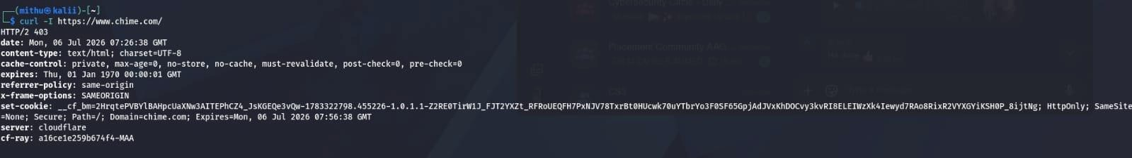
Figure 4.5: Raw HTTP response headers showing active edge protection parameters.

Directory Enumeration (Gobuster)

To discover hidden directories, application paths, and accessible source endpoints, brute-force enumeration was conducted on the active handbooks subdomain.

Tool Used: Gobuster (v3.8.2)

Command Executed:
gobuster dir -u https://handbooks.chime.com -w
/usr/share/wordlists/dirb/common.txt --exclude-length 1337

Methodology & Impact: Utilizing a common directory wordlist while filtering out dead lengths,
Gobuster mapped out the remote file path layout. The scan uncovered crucial active directories: /assets (Status: 301 Redirect), robots.txt (Status: 200 OK), and a custom sitemap.xml endpoint.
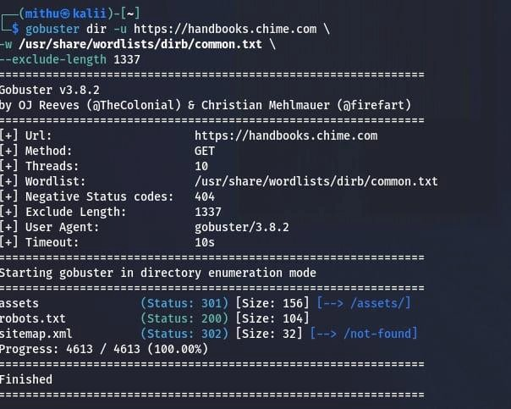
Figure 4.6: Gobuster directory brute-force successfully discovering hidden paths.

AUTOMATED VULNERABILITY ASSESSMENT

Configuration Auditing (Nikto)

A comprehensive web server audit was executed to detect missing security updates, sub-optimal settings, and certificate information.

Tool Used: Nikto (v2.6.0)

Command Executed:
nikto -h https://www.chime.com

Methodology & Impact: Nikto mapped out the active SSL certificate data, showing a valid Let's Encrypt deployment covering all wildcard domains (*.chime.com). However, due to aggressive scanning signatures, Cloudflare's protective layer flagged the traffic, triggering an early connection shutdown (Error limit 20 reached), highlighting active perimeter rate-limiting.

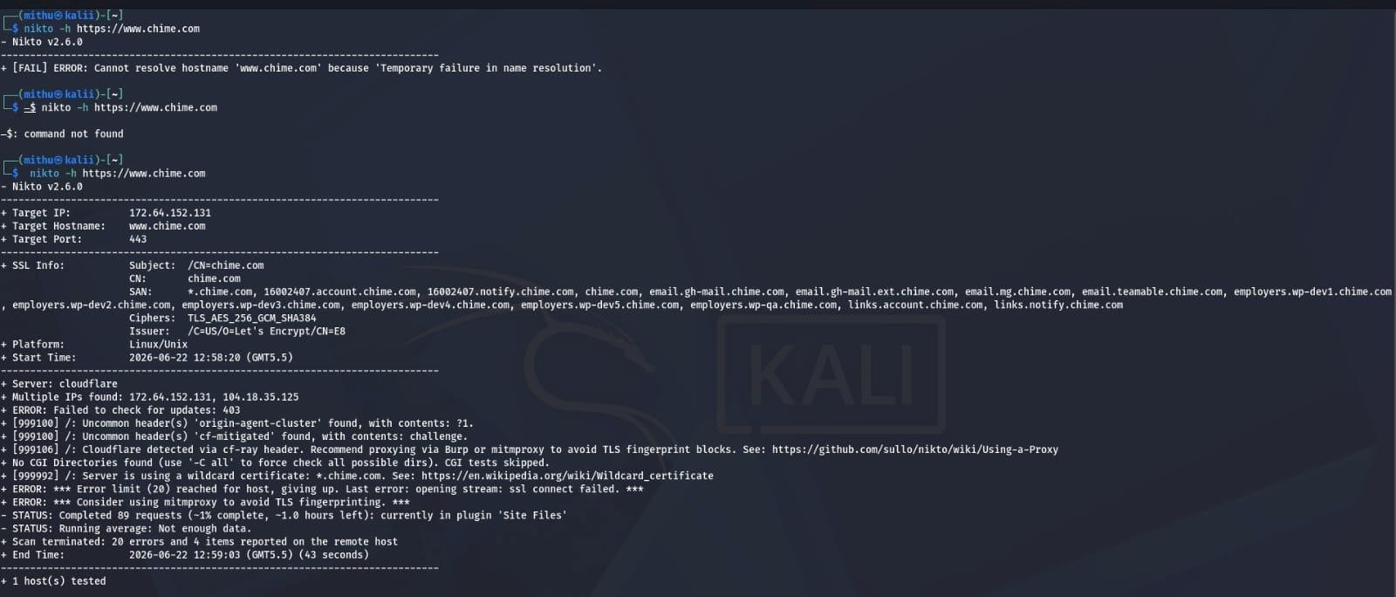
Figure 5.1: Nikto web auditing log indicating certificate coverage and WAF defense.

Template-Based Vulnerability Scanning (Nuclei)

To run targeted threat signature identification against the primary perimeter, a template-based vulnerability assessment was launched.

Tool Used: Nuclei (v3.8.0) by ProjectDiscovery

Command Executed:
nuclei -u https://www.chime.com

Methodology & Technical Findings: The Nuclei engine parallelly parsed system templates against the live host. While the edge successfully enforced a waf-detect:cloudflare alert, the scan successfully highlighted deep application-layer policy exposures:
Missing Security Headers (http-missing-security-headers): Flagged a lack of strict default transport security boundaries across secondary paths.
Weak Content Security Policy (weak-csp-detect:unsafe-script-src): Identified structural weaknesses within the CSP rules, explicitly allowing insecure keywords like 'unsafe-inline' and 'unsafe-eval', lowering browser defense against Cross-Site Scripting (XSS).
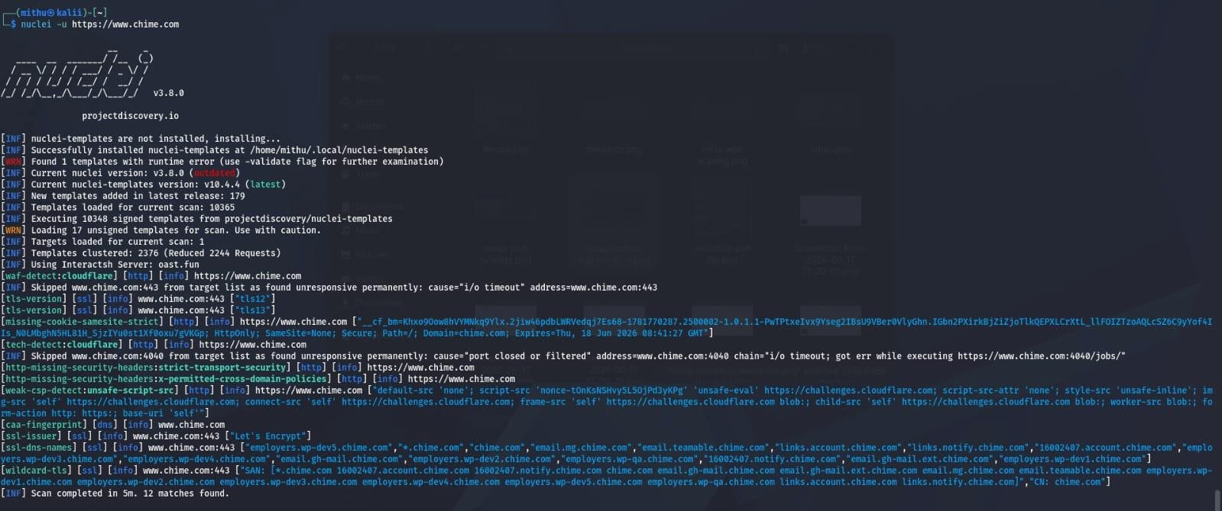
Figure 5.2: Nuclei automated scanner capturing missing security headers and loose CSP alerts.

MANUAL VERIFICATION & DETAILED ANALYSIS

To eliminate false positives from automated scans, low-level inspection was performed against the live handbooks.chime.com node.

Information Disclosure & Policy Injection Audit

Verification Command:
curl -i https://handbooks.chime.com

Analysis & Critical Gaps Identified: Manual payload verification confirmed the exact technical vulnerabilities present in the active deployment stack:

- Framework Fingerprint Exposure: The response header explicitly exposes x-powered-by: Express. This leaks that the backend runtime is running Node.js/Express, allowing targeted exploit planning.

- Weak Client-Side Directives: The raw source code analysis verified the automated alert. The content-security-policy contains loose directives authorizing style-src 'unsafe-inline', which bypasses standard script protection.
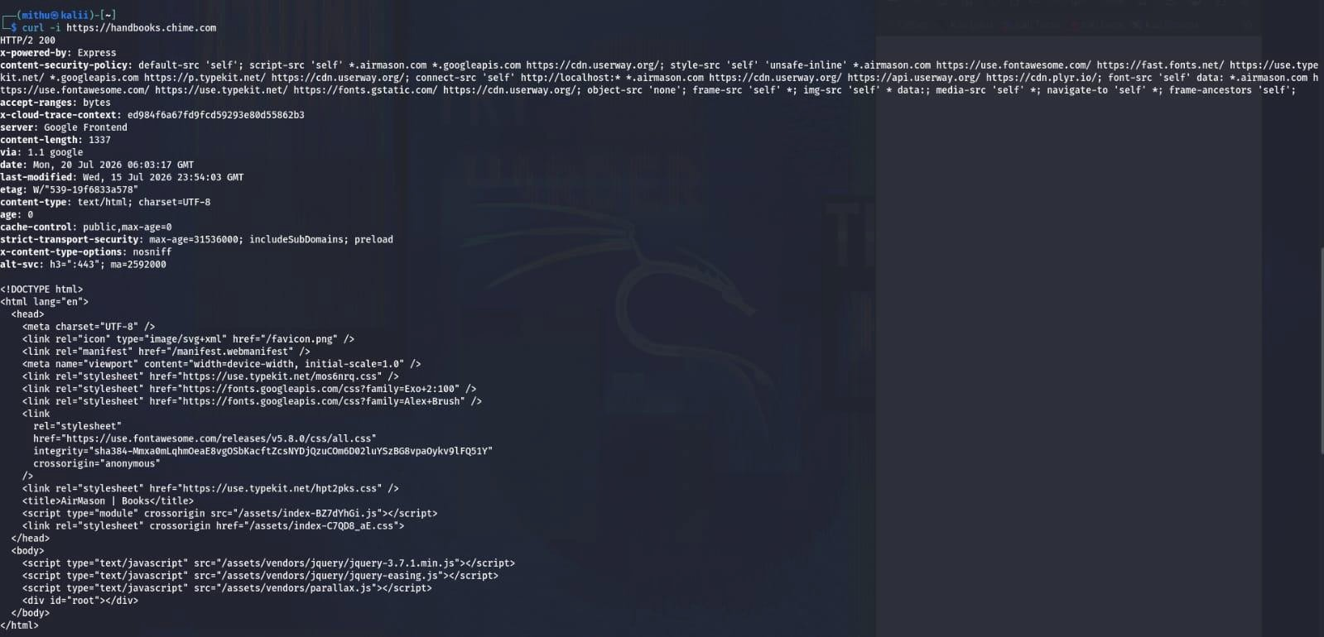
Figure 6.1: Raw source code and header stream verification mapping framework exposure.

REMEDIATION ACTION PLAN

Based on the validated findings from the VAPT workflow, the following hardening steps are mandatory:

- Deactivate Framework Signatures:
To prevent banner-grabbing exploits, disable the X-Powered-By header in the Express JS application stack:
const express = require('express'); const app = express(); app.disable('x-powered-by');

- Harden Content Security Policy (CSP):
Re-engineer the CSP configuration to eliminate loose execution parameters. Remove 'unsafe-inline' and 'unsafe-eval' from the script/style definitions and enforce standard source restrictions:
Content-Security-Policy: default-src 'self'; script-src 'self' https://trustedscripts.com; object-src 'none

8.TABLE

SI.NO | Vulnerability | Severity | Status
1 | Express framework Disclosure | Low | Identified
2 | Missing Content Security policy | Low | Identified
3 | Cloudflare protection | Information | verified

9.CONCLUSION

The VAPT project conducted on the chime.com infrastructure successfully evaluated its perimeter defense posture. The automated scanning and manual validation phases confirmed a highly resilient external layer managed by Cloudflare's proxy architecture. However, minor internal misconfigurations, such as explicit Express framework leakage and sub-optimal Content Security Policies, were verified on the active subdomain nodes. Implementation of the provided remediation steps will significantly minimize the application attack surface.

The assessment identified low-risk security misconfigurations rather than critical vulnerabilities. Continuous security monitoring, periodic VAPT assessments, and timely remediation of identified issues are recommended to maintain a strong security posture.

